

Macquarie University
School of Computing

COMP8230
Mining Unstructured Data
Session 1, 2026

Assignment 1

Byunghyun Hwang
48764388

Executive Summary
Traditional invasive methods for monitoring liver health, such as blood tests, are inconvenient for frequent and real-time tracking. To address these limitations, this report introduces a multimodal non-invasive liver health monitoring system utilizing a smart patch, a smartwatch, and embedded sensors. This system integrates sweat, arterial pattern, and motion data analysis to provide a comprehensive information, enabling users to regularly monitor their liver health.
A multi-output Random Forest Regression model was trained to predict key invasive biomarkers (Albumin, Cholesterol, and Triglycerides) utilizing synthetic sweat component data (Ammonia, Urea, Sodium, Chloride, Potassium, and Cortisol). While the overall model performance ($R^{2}$: 0.5290, MAE: 26.71) and the prediction of Triglycerides level prediction ($R^{2}$: 0.30, MAE: 28.89) showed relatively low accuracy due to the inherent limitations of synthetic data, the model demonstrated exceptional performance for Cholesterol ($R^{2}$: 0.88) and Albumin (MAE: 0.22). These results suggest that the model performance can be further improved with real-world sweat data.
To enhance the reliability of the sweat analysis, arterial pattern data is collected and analyzed as a supplementary indicator. The system identifies potential liver health risks when abnormal biomarker levels and arterial patterns are detected. Finally, motion data is utilized to remove background noise and identify user contexts (daily life vs physical exercise). This allows users to track liver health improvements specifically associated with physical exercise, which is highly recommended for liver patients.

AI Usage Statement
Generative AI (Gemini) was used in the preparation of this report for the following purposes.
- Polishing the English terminology and grammatical structures
- Generating the initial design drafts for Figures 1, 3, and 5
- Refining and formatting reference list

Table of Contents

1. Problem Background 3
2. Sources of Data 4
3. Motivating Scenario 5
4. Problem Statement 6
5. Approach 6
5.1 Model Training 6
5.2. Data Collection 7
5.3. Real-Time Feedback 7
6. Results/Prototypes 8
6.1. Biomarker Level Prediction Simulation 8
6.3.1. Noise Filtering 11
6.3.2. Context Identification 11
7. Conclusion 12
Reference 13

1. Problem Background
One death out of every twenty-five deaths worldwide comes from liver disease, indicating that approximately 4% of all death cases globally are caused by liver disease (Devarbhavi et al., 2023). Regarding Australia, approximately one-third of Australian population is affected by fatty liver disease and, among all cancers in Australia, liver cancer is one of the most rapidly increasing causes of cancer death (University of Queensland, n.d.). In Australia, merely 16% of patients diagnosed with liver cancer survive beyond 5 years and most cases are potentially preventable through early identification (University of Queensland, n.d.). This implies that early detection of liver cancer is challenging since it often remains ‘silent’ until irreversible damage has occurred. Currently, liver cancer can only be diagnosed through blood tests, imaging scans, and tissue sampling (biopsy) (Cancer Council South Australia, n.d.). This means that identifying liver cancer early is particularly challenging for people who do not have regular medical check-ups. A personal clinical case identifying an abnormal GGT (Gamma-glutamyl transferase) level highlights the limitations of current liver health monitoring system. This biomarker was identified during a routine medical check-up, signaling potential liver inflammation. Although blood tests, imaging scans, and tissue sampling (biopsy) were conducted, the underlying cause remained inconclusive. Fortunately, other biomarkers were within normal ranges. Since no specific medication exists for this stage, management focused on prescribed supplements and regular exercise, which successfully led to a gradual decrease in the GGT level. This experience demonstrates that early liver stress is manageable but it is difficult to track liver health without consistent monitoring. Early identification of liver disease is highly dependent on regular medical check-ups, which can be inaccessible for many, especially those in countries with high healthcare costs. Therefore, IoT technology, integrated with non-invasive methods, must be applied to continuously monitor liver health status and identify early abnormalities before they progress into critical liver disease.

2. Sources of Data
For continuous liver health monitoring in everyday life, this system utilizes non-invasive sensing technologies to collect unstructured data from three primary sources.
2.1. Sweat Components: Biochemical data including biomarkers and electrolyte shifts in sweat will be collected utilizing smart patches.
Ammonia & Urea: Smart patches equipped with biochemical sensors non-invasively collect real-time data on Ammonia and Urea levels (Rath et al., 2024). Specifically, potentiometric and enzymatic sensors are utilized to collect Ammonia and Urea data, respectively (Xu et al., 2021). A significant elevation of Ammonia with a simultaneous drop in Urea is a critical indicator of liver disease, especially when these biomarkers deviate from the established personalized baselines (Rath et al., 2024).
Sodium & Chloride: The primary components of sweat are Sodium and Chloride, representing the most abundant electrolytes in sweat (Xu et al., 2021). These data can be collected from sweat utilizing potentiometric sensors (Xu et al., 2021). Clinically, patients with advanced liver disease often have less sodium and too much water in their blood (John and Thuluvath, 2015).
Potassium: Potassium is a key biomarker used to track liver status (Kumar et al., 2025). Moreover, it is a predominant component of sweat, and its data can be non-invasively collected from sweat utilizing potentiometric sensors (Xu et al., 2021).
Cortisol: Cortisol is a key biochemical marker used to track liver status by monitoring physical stress in real-time (Kumar et al., 2025). This data can be non-invasively collected from sweat utilizing electrochemical biosensors (Xu et al., 2021).
2.2. Arterial Patterns: Physiological data will be collected utilizing smartwatches equipped with mmWave sensors. Rather than focusing on static diagnosis, these sensors track long-term trends in arterial wave patterns. Monitoring these longitudinal changes establishes a comprehensive baseline of the user’s vascular health, which serves to cross-verify and enhance the accuracy of the sweat analysis outcomes.
2.3. Motion Patterns: Movement data will be collected utilizing accelerometers and gyroscopes built into the smartwatches. These sensors are used to remove signal noise caused by physical movement to ensure the accuracy of the arterial pattern data. Moreover, they identify when the user is exercising, which helps in understanding the relationship between physical activity and liver health improvement.

3. Motivating Scenario
Liver diseases do not have significant physical symptoms until the liver has sustained irreversible damage. Unfortunately, the possibility of recovery drops drastically once physical symptoms become apparent. This “silence” of liver is not the only reason for prevention failure; current monitoring methods such as blood tests, imaging scans, and tissue sampling pose significant challenges. These methods are not only time-consuming and financially burdensome but also physically painful, particularly tissue sampling. These barriers frequently discourage people from seeking early medical check-ups, allowing liver damage to be unnoticed. To illustrate these challenges in a real-world context, consider a hypothetical case of an office worker. Through a regular medical check-up provided as an employee benefit, he identified that his GGT level was abnormally high due to non-alcoholic fatty liver disease (NAFLD). To improve his liver health, he consistently took prescribed liver supplements and engaged in intensive exercise. He regularly tracked his progress by visiting a hospital every six months. Although his GGT levels showed an overall decline, he encountered significant frustration since they fluctuated unpredictably between tests. Despite his access to a regular check-up, he was stressed by the uncertainty. He could not identify the specific reasons of these fluctuations. It was a challenge for him to determine which daily habits such as dietary choices, exercise types, or work-related stress were causing his GGT levels to spike or drop. This is where IoT technology needs to be applied to provide clinical value. If he had utilized a non-invasive smart patch and smartwatch, he could have monitored biomarkers in real time. An IoT system capable of collecting and analyzing data streams could identify the hidden patterns behind his GGT fluctuations. This would enable him to establish a personalized baseline and adjust his daily habits to manage his liver more effectively. Regarding business perspective, his doctor can manage his care more effectively, as these data patterns provide actionable information and insights to improve his liver health. Based on this case, the inherent limitations of traditional liver testing still result in uncertainty even when financial barriers are removed. Therefore, application of IoT for managing liver health not only encourages individuals to seek medical attention before liver damage becomes irreversible but also provides them with a personalized guideline to manage their liver health effectively on a daily basis.

4. Problem Statement
The fundamental problem in managing liver health is the lack of continuous liver data, leading to significant information gaps between medical visits. Biomarkers of the liver such as GGT level is highly influenced by daily habits; however, current diagnostic methods are infrequent and invasive. These limitations prevent both patients and clinicians from identifying particular triggers that cause liver damage. Since current methods miss the valuable insights provided by daily metabolic changes, there is an urgent need for proactive and continuous monitoring. Therefore, mining unstructured IoT data can be a solution to address the fundamental problem by attaining real-time feedback. However, while non-invasive IoT sensors can provide continuous feedback, the range of biomarkers they can collect is limited. Key liver health indicators that are found through invasive methods cannot be fully replaced by non-invasive methods alone. To overcome these limitations, an integrated monitoring system is required to bridge the gap. The system can achieve higher accuracy in tracking liver health by mining unstructured IoT data from non-invasive methods and correlating it with invasive data. This system is a supplement tool to frequently track liver health and identify the reasons for fluctuations between medical check-ups, rather than a perfect replacement. This approach still relies on invasive methods for high accuracy while utilizing continuous non-invasive data, enabling more effective liver management.

5. Approach
According to the research conducted by Kumar et al. (2025), Albumin, Cholesterol, and Triglycerides are identified as the key biomarkers for monitoring liver health. In our approach, non-invasive IoT data will be correlated with these key invasive features to overcome the inherent accuracy limitations of unstructured IoT data. Since our strategy focuses on predicting these key invasive features by utilizing non-invasive data mentioned in the “Sources of Data”, establishing this correlation will leverage the advantages of both data types, effectively bridging the clinical gap between intermittent invasive testing and continuous non-invasive monitoring. Prediction of these key biomarkers through non-invasive data will enable both patients and clinicians to monitor the potential risk of liver disease. Although this predictive approach does not make a definitive clinical diagnosis, it works as a proactive guide for early intervention and medical consultation before liver is seriously damaged.

5.1 Model Training
The initial phase of this approach is to collect non-invasive sweat data including Ammonia, Urea, Sodium, Chloride, Potassium, and Cortisol from diagnosed liver patients. Then, these features will be utilized to train a predictive model, with clinical invasive data (Albumin, Cholesterol, and Triglycerides) serving as ground-truth labels. For this approach, the Random Forest (RF) model is selected. This choice is grounded in the findings of Kumar et al. (2025), where RF showed significant performance, achieving a balanced F1-score of 87% in classifying liver disease. Furthermore, RF is commonly embedded into edge computing systems due to its energy efficiency and rapid processing time (Hassan et al., 2025).

5.2. Data Collection
As users wear a smart patch on their arms, the integrated microfluidic chips naturally absorb sweat via capillary action through micro-channels and transport it to the sensing region for analysis (Umapathi et al., 2025). Once sweat reaches sensors, it is converted into the bio-electrical signals. Then, these signals are filtered, amplified, and turned into digital data (Umapathi et al., 2025). Finally, near-field communication (NFC) transmits this digital data to a smartwatch (Umapathi et al., 2025). Simultaneously, a smartwatch equipped with mmWave sensors collects arterial pattern data. By utilizing the reflected signals, the system captures micro-level physiological movements, allowing for the precise detection of the expansions and contraction cycles of the artery (Ji et al., 2025). To remove noise and fluctuations, the accelerometer and gyroscope integrated into the smartwatch detect abnormal physical patterns. These sensors act as a reference to determine whether data fluctuations represent a true physiological change rather than motion artifacts (Polvorinos-Fernández et al., 2025).

5.3. Real-Time Feedback
Once a smartwatch receives sweat data from the smart patch, and collects arterial pattern and movement data, it transmits the integrated dataset to an edge server. Edge computing facilitates offloading heavy data processing to overcome the computational limitations of mobile devices; as an essential component of this architecture, the edge server executes complex algorithms to ensure a real-time response (Kong et al., 2022). On the edge server, a Random Forest (RF) model predicts the levels of key metabolic biomarkers (Albumin, Cholesterol, and Triglycerides) by analyzing the sweat data. Simultaneously, for the arterial data, the system uses signal pattern analysis to detect the expansion and contraction cycles of the artery, prioritizing real-time efficiency over heavy deep learning algorithms. Lastly, the motion data is analyzed to determine physical intensity, providing essential contextual information to validate whether the fluctuations in the sweat and arterial data represent true physiological signals or are artifacts induced by movement. Since collecting data when users do exercise is significant for effective liver health management, this motion-aware validation is crucial. By integrating these multimodal outcomes, the edge server transmits the final outcomes back to the smartwatch, informing the user if a clinical consultation for liver health is required. This integrated system is designed to ensure that each sensor complements the others, thereby optimizing diagnostic reliability.

6. Results/Prototypes
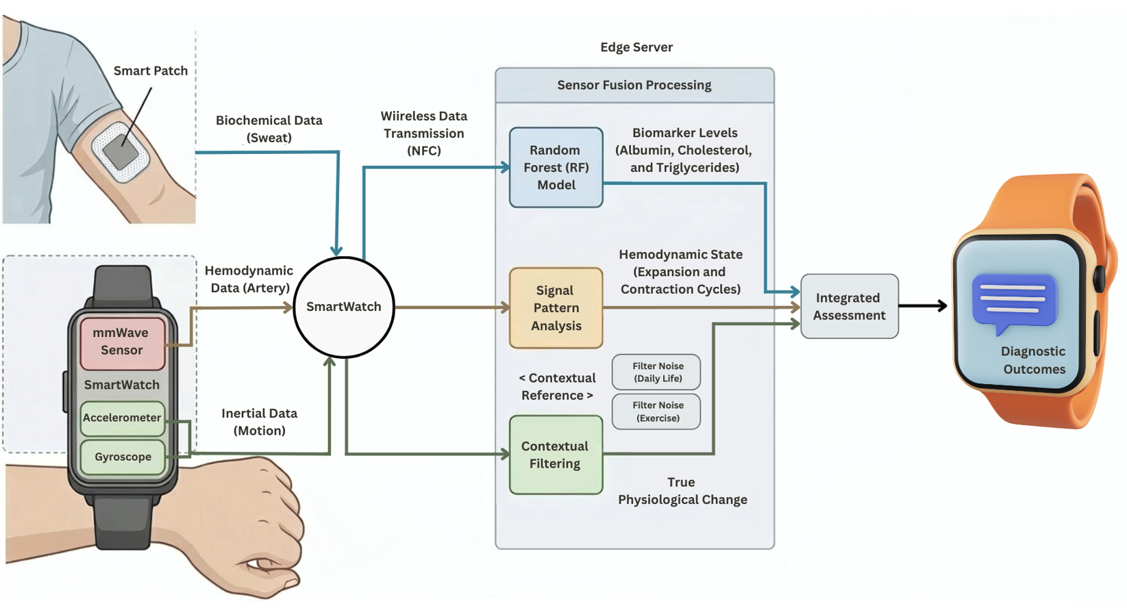
Figure 1: Non-Invasive Liver Health Monitoring System Flow
This diagram illustrates the comprehensive architecture of the multimodal liver health monitoring system. Biochemical data is collected from a smart patch and transmitted to the smartwatch through NFC. Simultaneously, the smartwatch captures arterial hemodynamic signals and inertial motion data. All collected data is transmitted to an edge server for complex analytics. A random forest model processes the biochemical data to predict key biomarkers, while the arterial signals are analyzed to monitor hemodynamic states. The inertial motion data serves as contextual reference, allowing the system to identify daily life and exercise contexts. The system utilizes adaptive noise filtering to both contexts. Filtered data are categorized and stored separately. Daily life data provides a relatively accurate baseline for liver health assessment, while exercise data tracks dynamic metabolic and liver recovery. These integrated data are used to create a comprehensive liver health report, offering detailed figures and personalized liver health assessments.

6.1. Biomarker Level Prediction Simulation
A multi-output Random Forest Regression model was developed to simulate biomarker level predictions. The model was trained using the Liver Cirrhosis Stage Classification dataset (Velu, 2023), originally sourced from a Mayo Clinic study on Primary Biliary Cholangitis (PBC). The dataset was retrieved via Kaggle to obtain clinical data for Albumin, Cholesterol, and Triglycerides from real liver patients. To bridge the gap between non-invasive sweat data and invasive clinic data, a synthetic sweat dataset was generated. The baseline values and normal ranges for sweat components were decided based on the physiological data provided by Baker et al., (2022). Weights were allocated to simulate the correlations between sweat components and the key biomarkers; for example, a weight was applied to reflect the correlation that a decrease in Albumin indicates a decline in liver health. The overall performance of the model (total $R^{2}$: 0.5290) is relatively moderate, primarily due to the inherent limitations of synthetic sweat data. However, the model shows a high explanatory power for Cholesterol with an $R^{2}$ of 0.88. While the $R^{2}$ for Albumin (0.44) is lower, the MAE is significantly low at 0.22, indicating that the predictions are close to the actual values. In contrast, the prediction for Triglycerides levels showed relatively low accuracy ($R^{2}$: 0.30, MAE: 28.89), indicating that the correlation between sweat data and Triglycerides is difficult to be identified with synthetic data. These results suggest that the model’s performance and accuracy could be improved if it is trained with real-world sweat-blood paired data.
 | Total | Albumin | Cholesterol | Triglycerides
R2 | 0.5290 | 0.41 | 0.88 | 0.30
MAE | 26.71 | 0.22 | 51.02 | 28.89
Table 1: RF Model Performance
This system is designed to trigger automated clinical notices when predicted values exceed normal ranges based on the physiological data provided by Cleveland Clinic (2022a, 2022b, 2022c). Furthermore, it implements a longitudinal analysis by comparing current data with the user’s average monthly and yearly records. This enables users to monitor whether their liver health is improving or requires medical attention.
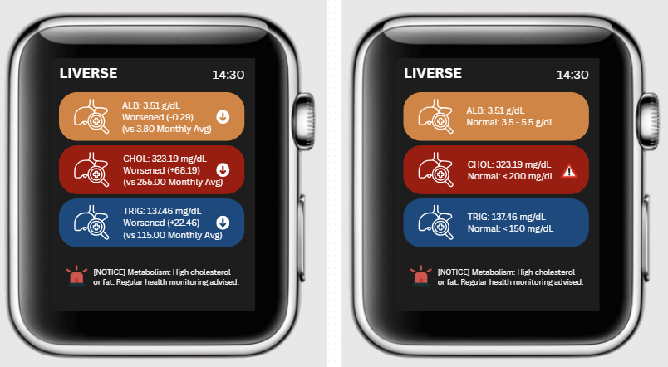
Figure 2: Monthly Status and General Status Analysis

6.2. Arterial Pattern Simulation
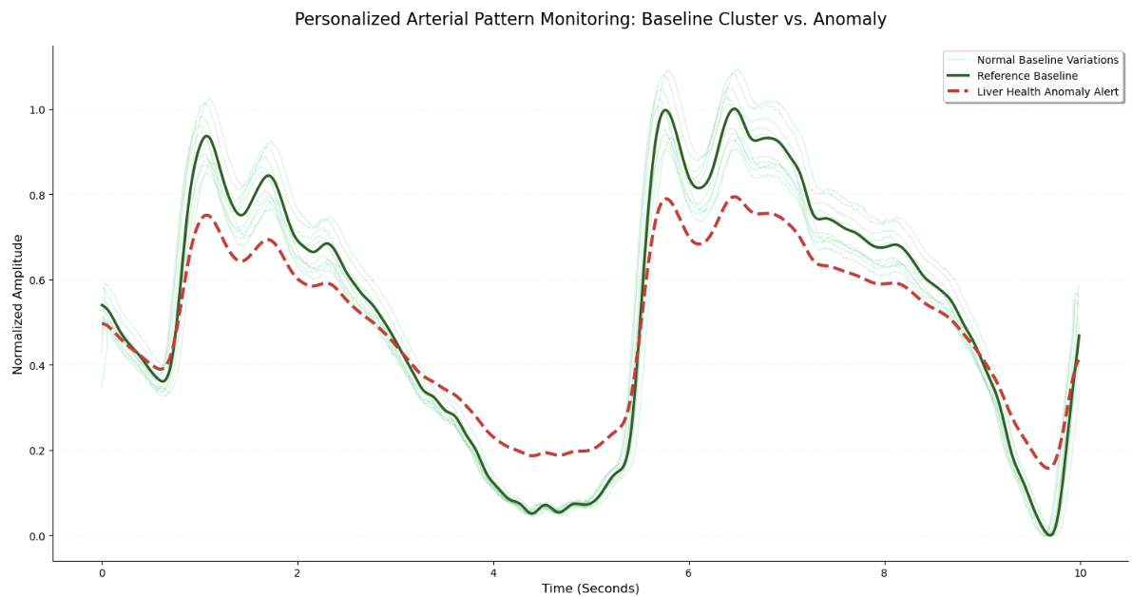
Figure 3: Simulation of Arterial Pattern.
The system collects a user’s arterial patterns and compares them against personalized baseline pattern. For this simulation, the PPG Signal dataset (Capurro, 2021) was retrieved via Kaggle to establish a representative baseline of normal blood flow. Since the clinical background of the volunteers in the dataset is not specified, it is assumed that these pattern data is healthy baseline references. The dataset consists of blood flow patterns measured from the index fingers of human volunteers. Although the final system utilizes a mmWave sensor, PPG data was chosen for two reasons. Firstly, public mmWave datasets are limited and exceed 100GB, which is impractical for this scope of analysis. Second, while PPG and mmWave have different operating principles, they both measure the same movement of blood vessels. Therefore, it is assumed that the shape of the patterns from both sensors will be similar. To remove high-frequency noise, a Butterworth low-pass filter was implemented. To demonstrate the system’s working procedure, the transparent green variations and the red anomaly line were created for comparison. In the visualization, the solid green line represents the user’s core baseline, while the multiple transparent green lines show normal daily variations. In contrast, the red line indicates an abnormal pattern where blood is not flowing properly through the liver. When the mmWave sensor detects such deviations, the system sends a health alert to the user’s smartwatch.
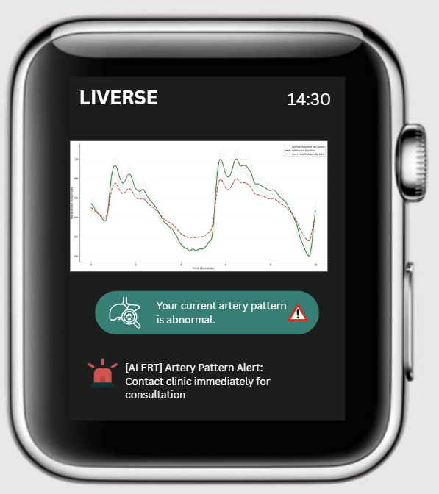
Figure 4: Arterial Pattern Analysis

6.3. Motion Data Simulation
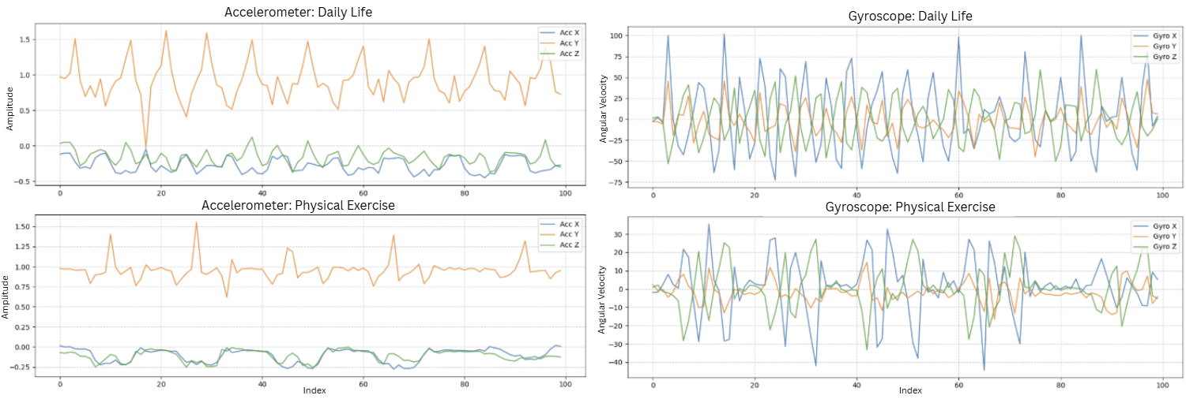
Figure 5: Simulation of Motion Pattern (Accelerometer and Gyroscope)
The motion sensors (accelerometer and gyroscope) in a smartwatch play a critical role in ensuring that liver health analysis is accurate and personalized. The system leverages two logics to acquire high-purity diagnostic pattern signals. For this simulation, the Fitness Tracker – Accelerometer and Gyroscope dataset (Jeniya, 2024) was retrieved via Kaggle to compare motion patterns between daily life and exercise contexts. In this dataset, ‘medium’ and ‘heavy’ intensity exercise data were used to represent daily life and physical exercise, respectively. This decision was based on the observation that while heavy exercise requires higher physical force, it shows structured and repetitive patterns. In contrast, daily life (medium intensity) shows more stochastic and irregular movements. Accordingly, a more sophisticated noise filtering approach is required for daily life context.

6.3.1. Noise Filtering
The motion sensors (accelerometer and gyroscope) are constantly monitoring the user’s arm movements across X, Y, and Z axes. The system compares real-time movement with the user’s established personalized baseline movement pattern. By detecting and eliminating small and random variations, the sensors ensure that significant sweat composition data and arterial pattern data remain clean and uncontaminated for accurate analysis. As demonstrated in the motion pattern comparison, daily life patterns fluctuate more than structured physical exercise patterns (see Figure 5). Therefore, the system applies a more intensive noise-filtering algorithm to the daily life context to ensure the purity of the diagnostic signals.

6.3.2. Context Identification
Beyond simple noise-filtering, the sensors are utilized to identify the specific context of the user’s activity. By comparing real-time motion signals against the personalized baseline, the system distinguishes whether the user is engaged in daily activities or physical exercise. If the movement pattern fluctuates with high irregularity (as seen in the daily life context graphs), the system recognizes it as daily life. In contrast, regular and high-amplitude patterns are identified as physical exercise, and the data is specifically classified into this exercise context for tracking health progress. This classification is a critical feature, as it enables the system to track liver health progress specifically during physical exercise, rather than dismissing physiological changes as mere noise. However, the current identification logic is based on the simple hypothesis that daily life activities show more complex movement fluctuations than structured physical exercise. While this is true in most cases, this simplified approach may not account for all environmental variables, and distinguishing every scenario is technically challenging. These limitations will be addressed in future work through the integration of more advanced motion sensors and sophisticated motion data processing techniques.
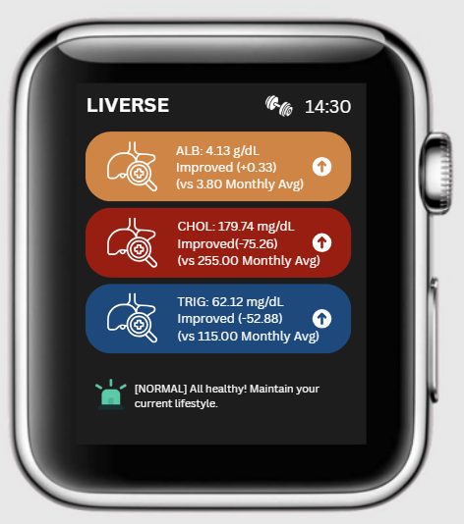
Figure 6: Exercise Context Analysis

7. Conclusion
This multimodal liver health monitoring system is designed to bridge the gaps between non-invasive and invasive methods of monitoring liver health. A multi-output Random Forest Regression model was trained with a dataset combining an invasive liver dataset of real liver patients and synthetic sweat data to predict levels of key invasive biomarkers (Albumin, Cholesterol, and Triglycerides) for a simulation test. While the overall model performance was not significant due to the inherent limitations of synthetic sweat data, the model had a high explanatory power for Cholesterol and predicted Albumin levels close to true Albumin levels. In contrast, the prediction level of Triglycerides was less accurate. These outcomes demonstrate that the model performance could be improved with real sweat data. The predicted levels are used to monitor users’ liver health status and progress based on monthly/yearly records or the general levels of the key biomarkers. Then, arterial pattern data is analyzed to enhance the reliability of the sweat data analysis. The identification of abnormal prediction levels and arterial patterns indicates potential risks of liver disease. Finally, motion data is analyzed to identify and remove background noise causing data contamination. Beyond noise elimination, motion data is analyzed to classify collected sweat and arterial pattern data into daily life and physical exercise contexts. Although the motion data plays a significant role filtering clean data and providing valuable insights, the development of advanced sensors is still required to enhance the system reliability, especially in distinguishing contexts.

Reference

Baker, L. B., Engel, M. D., & Wolfe, A. S. (2022). Sweat as a Diagnostic Tool: Biological Realities and Technological Challenges. Sports Science Exchange #226. Gatorade Sports Science Institute.
Cancer Council South Australia. (n.d.). Liver cancer (primary). https://www.cancersa.org.au/about-cancer/types-of-cancer/liver-cancer-primary
Capurro, L. (2021). PPG Signal Dataset. Kaggle. https://www.kaggle.com/datasets/lucilacapurro/ppg-signal-dataset
Cleveland Clinic. (2022a). Albumin Blood Test. Retrieved from https://my.clevelandclinic.org/health/diagnostics/22390-albumin-blood-test
Cleveland Clinic. (2022b). Cholesterol Numbers: What Do They Mean? Retrieved from https://my.clevelandclinic.org/health/articles/11920-cholesterol-numbers-what-do-they-mean
Cleveland Clinic. (2022c). Triglycerides. Retrieved from https://my.clevelandclinic.org/health/articles/11117-triglycerides
Devarbhavi, H., Asrani, S. K., Arab, J. P., Nartey, Y. A., Pose, E., & Kamath, P. S. (2023). Global burden of liver disease: 2023 update. Journal of Hepatology, 79(2), 516-533. https://doi.org/10.1016/j.jhep.2023.03.017
Hassan, U., Rehman, Z. U., Ahmad, I., & Islam, S. U. (2025). Analyzing the energy consumption of random forest and support vector machine models: paving the way for green and sustainable artificial intelligence. Discover Internet of Things, 5(100). https://doi.org/10.1007/s43926-025-00188-4
Jeniya, K. (2024). Fitness Tracker Accelerometer and Gyroscope Data. Kaggle. https://www.kaggle.com/datasets/krishujeniya/fitness-tracker-accelerometer-and-gyroscope -data
Ji, X., Dong, F., Huang, Z., Guo, X., Zhu, H., Chen, B., & Shen, J. (2025). Edge-assisted multi-user millimeter-wave radar for non-contact blood pressure monitoring. Applied Computing and Intelligence, 5(1), 57-76. https://doi.org/10.3934/aci.2025004
John, S., & Thuluvath, P. J. (2015). Hyponatremia in cirrhosis: Pathogenesis and management. World Journal of Gastroenterology, 21(11), 3197–3205. https://doi.org/10.3748/wjg.v21.i11.3197
Kong, X., Wu, Y., Wang, H., & Xia, F. (2022). Edge computing for Internet of Everything: A survey. IEEE Internet of Things Journal, 9(21), 20472-20485. https://doi.org/10.1109/JIOT.2022.3200431
Kumar, D., Bakariya, B., Verma, C., & Illes, Z. (2025). LivXAI-Net: An explainable AI framework for liver disease diagnosis with IoT-based real-time monitoring support. Computer Methods and Programs in Biomedicine, 270, 108950. https://doi.org/10.1016/j.cmpb.2025.108950
Polvorinos-Fernández, C., Sigcha, L., Borzì, L., Cardoso, P., Costa, N., Costa, S., López, J. M., Asensio, C., De Arcas, G., & Pavón, I. (2025). Diagnosis of resting tremor in Parkinson's disease using accelerometer and gyroscope sensors built into a smartwatch. In Biomedical Engineering Systems and Technologies (pp.460-481). Springer, Cham. https://doi.org/10.1007/978-3-031-96899-0_26
Rath, R. J., Herrington, J. O., Adeel, M., Güder, F., Dehghani, F., & Farajikhah, S. (2024). Ammonia detection: A pathway towards potential point-of-care diagnostics. Biosensors and Bioelectronics, 251, 116100. https://doi.org/10.1016/j.bios.2024.116100
Umapathi, A., Alshamsi, M., & Al-Qutayri, M. (2026). Smart patches for healthcare industry: a review of emerging technologies, challenges, and developmental opportunities. BioMedical Engineering OnLine, 24, 12. https://doi.org/10.1186/s12938-025-01485-3
University of Queensland. (n.d.). The silent threat in fatty liver disease. Institute for Molecular Bioscience. Retrieved March 7, 2026, from https://stories.uq.edu.au/imb/the edge/inflammation/silent-threat-in fatty-liver-disease/index.html
Velu, A. (2023). Liver Cirrhosis Stage Classification. Kaggle. https://www.kaggle.com/datasets/aadarshvelu/liver-cirrhosis-stage-classification
Xu, J., Fang, Y., & Chen, J. (2021). Wearable Biosensors for Non-Invasive Sweat Diagnostics. Biosensors, 11(8), 245. https://doi.org/10.3390/bios11080245

